**(CDD)**

LED String Animation

Contents

**1.** **Document History** 3

**1.1.** **Revision History Table** 3

**1.2.** **Current** **Document** **Status** 3

**2.** **Project Description** 3

**3.** **Block Diagram** 4

**4.** **Feature Description** 5

**4.1.** **Start Up Requirements** 5

**4.2.** **Tail Function Requirements** 8

**4.3. Turn Indicator (TI) Requirements** 10

**5.** **Reference Documents Table** 13

# **Document History**

## **Current Document Status**

|  |  |  |  |
| --- | --- | --- | --- |
| Version | Status | Author | **Date** |
| 1.0 | Draft | Caroline | 07/03/2020 |
| 1.1 | Draft | Caroline | 08/03/2020 |
| 1.2 | Draft | Hesham | 09/03/2020 |

## **Revision History Table**

|  |  |  |  |
| --- | --- | --- | --- |
| Version | Author | Date | Change |
| 1.0 | Caroline | 07/03/2020 | Initial Creation |
| 1.1 | Caroline | 08/03/2020 | Adding LED APIs’ flowcharts. |
| 1.2 | Hesham | 09/03/2020 | Flowcharts of SWITCH APIs are added. |

# **Reference Documents Table**

|  |  |  |  |
| --- | --- | --- | --- |
| Ref. number | Doc. Name | Version | Status |
| 1 | LED_String_GDD | 1.7 | proposed |

# **Project Description**

The project is composed of 3 sets of LED Strings Simulating the animation of LEDs in a Car, One set is named “Tail” and it simulates the animation of car’s back LEDs while the other 2 sets are named “Left TI” and “Right TI” is simulating the animation of left and right turn indicator in a car.

Each one of the 3 functions operates based on input signals coming from 3 switches named “Tail Switch”, “Left TI” and “Right TI” respectively in addition to “Welcome Mode” which shall operates one of 2 different modes based on the status of the mode switch. System layout is as shown in **Figure 1** below.

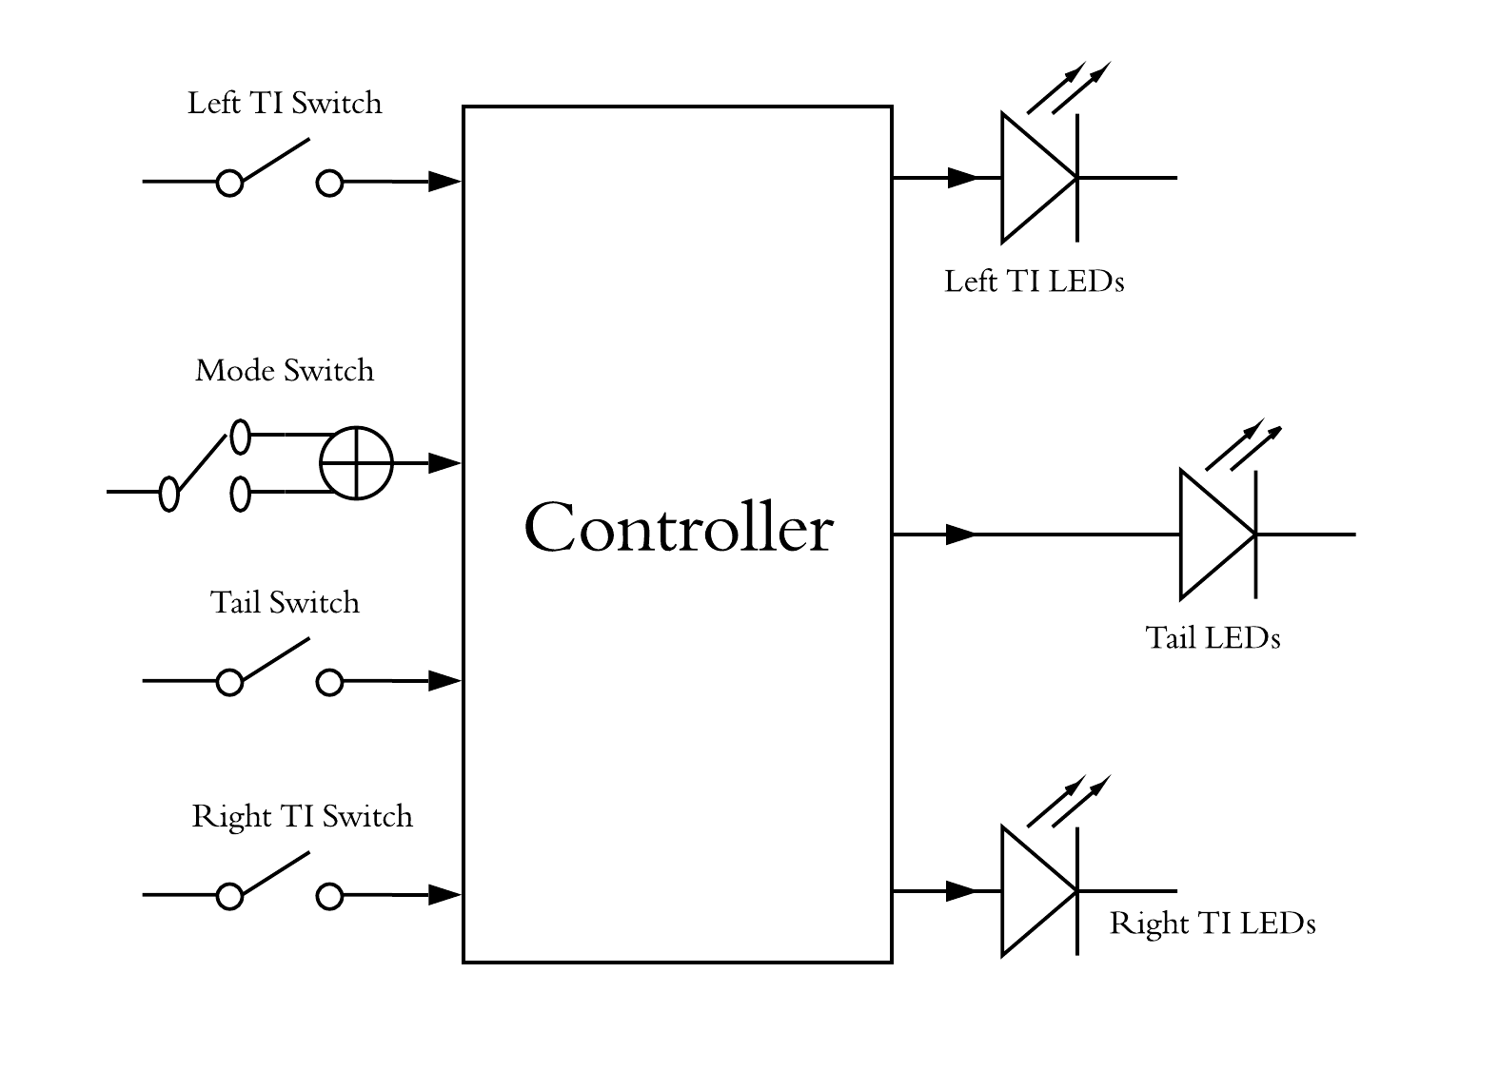

Figure 1: layout of the system

# **Software Context Diagram**

LEDs Manager

Switches Status

Handler

LEDs Status

LED Handler

Switch Manager

# **APIs**

* Delay

|  |  |  |
| --- | --- | --- |
| Name | void DELAY_ms(uint32_t time) | |
| Parameters | uint32_t time | 0-4,294,967,295 |
| Return Value | Void | |
| Description | Delays for a certain amount of time measured in milliseconds | |
| Req ID | Req_ PO5_LSAN_1_LED_STRING_GDD | |

* Std_Types

|  |  |  |
| --- | --- | --- |
| Name | ERROR_t | |
| Type | Enumeration | |
| Range | OK | 0 |
| NOK | 1 |
| Description | This User-defined data structure shall hold the Status of the returned error level form each API indicating success or failure of function completion and it should be either OK or Not OK. | |
| Req ID | Req_ PO5_LSAN_2_LED_STRING_GDD | |

* LED_Animation
  + User-defined Data Types

|  |  |
| --- | --- |
| Name | LEDString_t |
| Type | Structure |
| Range | - |
| Description | Data structure containing the set of configuration parameters required for setting the leds status |
| Req ID | Req_ PO5_LSAN_3_LED_STRING_GDD |

|  |  |  |
| --- | --- | --- |
| Name | LED_Animation_Tail_State | |
| Type | Enumeration | |
| Range | LED_ANIMATION_TAIL_ON | 0 |
| LED_ANIMATION_TAIL_OFF | 1 |
| Description | The state of the tail LEDs | |
| Req ID | Req_ PO5_LSAN_4_LED_STRING_GDD | |

|  |  |  |
| --- | --- | --- |
| Name | LED_Animation_Running_Mode | |
| Type | Enumeration | |
| Range | LED_ANIMATION_MODE_WELCOME_1 | 0 |
| LED_ANIMATION_MODE_WELCOME _2 | 1 |
| LED_ANIMATION_MODE_TI_1 | 2 |
| LED_ANIMATION_MODE_TI_2 | 3 |
| LED_ANIMATION_MODE_NONE | 4 |
| Description | The state of the TI LEDs | |
| Req ID | Req_ PO5_LSAN_5_LED_STRING_GDD | |

* + Function definitions

|  |  |  |
| --- | --- | --- |
| Name | ERROR_t LED_Animation_Init(void) | |
| Parameters | Void | |
| Return Value | ERROR_t | 0-1 |
| Description | Initializes all the LEDs and Switches required for the application | |
| Req ID | Req_ PO5_LSAN_6_LED_STRING_GDD | |

|  |  |  |
| --- | --- | --- |
| Name | ERROR_t LED_Animation_SetFlags(void) | |
| Parameters | Void | |
| Return Value | ERROR_t | 0-1 |
| Description | Reads all the switches status and sets all the flags that represents the LEDs animation | |
| Req ID | Req_ PO5_LSAN_7_LED_STRING_GDD | |

|  |  |  |
| --- | --- | --- |
| Name | ERROR_t LED_Animation_StartAnimationMode(void) | |
| Parameters | Void | |
| Return Value | ERROR_t | 0-1 |
| Description | Reads all the flags status and starts the suitable animation mode according to switches status | |
| Covers | Req_ PO5_LSAN_ SRS_Start welcome mode 1_02-V02  Req_ PO5_LSAN_ SRS_Start welcome mode 2_02-V02 | |
| Req ID | Req_ PO5_LSAN_8_LED_STRING_GDD | |

|  |  |  |
| --- | --- | --- |
| Name | ERROR_t LED_Animation_SetTailLeds(void) | |
| Parameters | Void | |
| Return Value | ERROR_t | 0-1 |
| Description | Sets the tail leds on and off according to the tail flag state | |
| Covers | [Req_ PO5_LSAN_ LED STRING ANIMATION_03_V01]  [Req_ PO5_LSAN_ LED STRING ANIMATION_04_V01] | |
| Req ID | Req_ PO5_LSAN_9_LED_STRING_GDD | |

|  |  |  |
| --- | --- | --- |
| Name | ERROR_t LED_Animation_RunModeOne(void) | |
| Parameters | Void | |
| Return Value | ERROR_t | 0-1 |
| Description | Runs the animation of mode 1 which is described in the LED_STRING_ANIMATION_CYRS | |
| Covers | [Req_ PO5_LSAN_ LED STRING ANIMATION_01_V01] | |
| Req ID | Req_ PO5_LSAN_10_LED_STRING_GDD | |

|  |  |  |
| --- | --- | --- |
| Name | ERROR_t LED_Animation_RunModeTwo(void) | |
| Parameters | Void | |
| Return Value | ERROR_t | 0-1 |
| Description | Runs the animation of mode 2 which is described in the LED_STRING_ANIMATION_CYRS | |
| Covers | [Req_ PO5_LSAN_ LED STRING ANIMATION_02_V01] | |
| Req ID | Req_ PO5_LSAN_11_LED_STRING_GDD | |

|  |  |  |
| --- | --- | --- |
| Name | ERROR_t LED_Animation_RunTI_Right(void) | |
| Parameters | Void | |
| Return Value | ERROR_t | 0-1 |
| Description | Runs the animation of TI right mode which is described in the LED_STRING_ANIMATION_CYRS until the TI right switch is released | |
| Covers | [Req_ PO5_LSAN_ LED STRING ANIMATION_05_V02]  [Req_ PO5_LSAN_ LED STRING ANIMATION_06_V01] | |
| Req ID | Req_ PO5_LSAN_12_LED_STRING_GDD | |

|  |  |  |
| --- | --- | --- |
| Name | ERROR_t LED_Animation_RunTI_Left(void) | |
| Parameters | Void | |
| Return Value | ERROR_t | 0-1 |
| Description | Runs the animation of TI left mode which is described in the LED_STRING_ANIMATION_CYRS until the TI left switch is released | |
| Covers | [Req_ PO5_LSAN_ LED STRING ANIMATION_07_V02]  [Req_ PO5_LSAN_ LED STRING ANIMATION_08_V01] | |
| Req ID | Req_ PO5_LSAN_13_LED_STRING_GDD | |

* LED
  + User-defined Data Types

|  |  |  |
| --- | --- | --- |
| Name | LED_t | |
| Type | Structure | |
| Attributes | Uint8_t pinNum | 0-8 |
| Uint8_t portName | ‘A’-‘D’ |
| Uint8_t activeState | 0-1 |
| Description | This User-defined data structure shall hold the configurations of the LED pin. | |
| Req ID | Req_ PO5_LSAN_14_LED_STRING_GDD | |

* + Function definitions

|  |  |  |
| --- | --- | --- |
| Name | ERROR_t LED_Init(uint8_t ledNumber) | |
| Parameters | Uint8_t ledNumber | 0-255 |
| Return Type | ERROR_t | 0-1 |
| Description | This API shall take the led number of a certain led and initialize DIO pins according to the data included in that structure like the pin number and port name. This API should return OK in case of successful pin configuration and NOK in case of invalid input configurations. | |
| Req ID | Req_ PO5_LSAN_15_LED_STRING_GDD | |

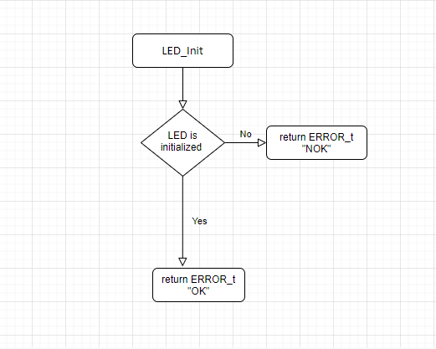

|  |  |  |
| --- | --- | --- |
| Name | ERROR_T LED_SetLedON(uint8_t ledNumber) | |
| Parameters | Uint8_t ledNumber | 0-255 |
| Return Value | ERROR_t | 0-1 |
| Description | Turn a specific LED ON | |
| Covers | Req_ PO5_LSAN_ SRS_Start welcome mode 1_02-V02  Req_ PO5_LSAN_ SRS_Start welcome mode 2_02-V02  Req_ PO5_LSAN_ SRS_Tail function ON_02-V02  Req_ PO5_LSAN_ SRS_Right Turn Indicator On_02-V01  Req_ PO5_LSAN_ SRS_ Left Turn Indicator On_02-V01 | |
| Req ID | Req_ PO5_LSAN_16_LED_STRING_GDD | |

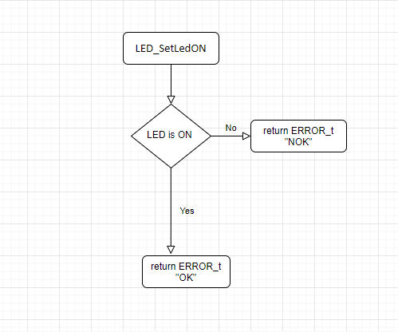

|  |  |  |
| --- | --- | --- |
| Name | ERROR_t LED_ SetLedOFF(uint8_t ledNumber) | |
| Parameters | Uint8_t ledNumber | 0-255 |
| Return Value | ERROR_t | 0-1 |
| Description | Turn a specific LED OFF | |
| Covers | Req_ PO5_LSAN_ SRS_Start welcome mode 1_02-V02  Req_ PO5_LSAN_ SRS_Start welcome mode 2_02-V02  Req_ PO5_LSAN_ SRS_Tail function OFF_01-V02  Req_ PO5_LSAN_ SRS_Right Turn Indicator On_02-V01  Req_ PO5_LSAN_ SRS_ Left Turn Indicator On_02-V01  Req_ PO5_LSAN_ SRS_ Left Turn Indicator On_02-V01  Req_ PO5_LSAN_ LED STRING ANIMATION_05_V02 | |
| Req ID | Req_ PO5_LSAN_17_LED_STRING_GDD | |

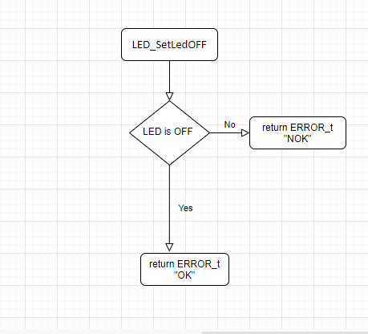

* Switch
* User-defined Data Types

|  |  |  |
| --- | --- | --- |
| Name | SWITCH_t | |
| Type | Structure | |
| Attributes | Uint8_t pinNum | 0-8 |
| Uint8_t portName | ‘A’-‘D’ |
| Uint8_t activeState | 0-1 |
| Uint8_t mode | 0-2 |
| Description | This User-defined data structure shall hold the configurations of the switch pin. | |
| Req ID | Req_ PO5_LSAN_18_LED_STRING_GDD | |

* Functions’ Description

|  |  |  |
| --- | --- | --- |
| Name | ERROR_t SWITCH_Init(uint8_t switchNumber) | |
| Parameters | Uint8_t switchNumber | 0-255 |
| Return Type | ERROR_t | 0-1 |
| Description | This API shall take the switch number of a certain switch and initialize DIO pins according to the data included in that structure like the pin number and port name as well as the mode of switch connection either input high impedence, pull-up or pull-down configurations. This API should return OK in case of successful pin configuration and NOK in case of invalid input configurations. | |
| Req ID | Req_ PO5_LSAN_19_LED_STRING_GDD | |

|  |  |  |
| --- | --- | --- |
| Name | ERROR_t SWITCH_Read(uint8_t switchNum, uint8_t* status) | |
| Parameters | Uint8_t switchNum | 0-255 |
| Uint8_t* status | Address of (0-1) |
| Return Type | ERROR_t | 0-1 |
| Description | This API shall read the status of a certain switch and assign its status (High/Low) to the pointer taken and return indication of Success/Failure of the reading operation or the validity of inputs. | |
| Covers | Req_ PO5_LSAN_ SRS_Start welcome mode 1/2_01-V02  Req_ PO5_LSAN_ SRS_Start welcome mode 2_01-V02  Req_ PO5_LSAN_ SRS_Tail function(ON/OFF)_01-V02  Req_ PO5_LSAN_ SRS_Right Turn Indicator On_01-V01  Req_ PO5_LSAN_ SRS_ Left Turn Indicator On_02-V01 | |
| Req ID | Req_ PO5_LSAN_20_LED_STRING_GDD | |

* DIO
  + Functions’ Description

|  |  |  |
| --- | --- | --- |
| Name | ERROR_t DIO_SetPinDir(uint8_t pinNum, uint8_t portName, uint8_t direction) | |
| Parameters | Uint8_t pinNum | 0-8 |
| Uint8_t portName | ‘A’-‘D’ |
| Uint8_t direction | 0-1 |
| Return Value | ERROR_t | 0-1 |
| Description | Configures the Pin Direction Input/Output | |
| Req ID | Req_ PO5_LSAN_21_LED_STRING_GDD | |

|  |  |  |
| --- | --- | --- |
| Name | ERROR_t DIO_SetPinVal(uint8_t pinNum, uint8_t portName, uint8_t value) | |
| Parameters | Uint8_t pinNum | 0-8 |
| Uint8_t portName | ‘A’-‘D’ |
| Uint8_t value | 0-1 |
| Return Value | ERROR_t | 0-1 |
| Description | Configures the Pin Value High/ Low | |
| Req ID | Req_ PO5_LSAN_22_LED_STRING_GDD | |

|  |  |  |
| --- | --- | --- |
| Name | ERROR_t DIO_GetPinVal(uint8_t pinNum, uint8_t portName, uint8_t* value) | |
| Parameters | Uint8_t pinNum | 0-8 |
| Uint8_t portName | ‘A’-‘D’ |
| Uint8_t* value | Address of (0-1) |
| Return Value | ERROR_t | 0-1 |
| Description | Reads the Pin Value High/Low | |
| Req ID | Req_ PO5_LSAN_23_LED_STRING_GDD | |

* External Interrupt

|  |  |  |
| --- | --- | --- |
| Name | ERROR_t E_IRQ_Init(void) | |
| Parameters | Void | |
| Return Value | ERROR_t | 0-1 |
| Description | Initializes the external interrupt pins configured. | |
| Req ID | Req_ PO5_LSAN_24_LED_STRING_GDD | |

|  |  |  |
| --- | --- | --- |
| Name | ERROR_t E_IRQ_SetCallback(Void (*callback)(void)) | |
| Parameters | Void (*callback)(void) | - |
| Return Value | ERROR_t | 0-1 |
| Description | Sets The Callback Function | |
| Req ID | Req_ PO5_LSAN_25_LED_STRING_GDD | |

# Flowcharts

* DIO

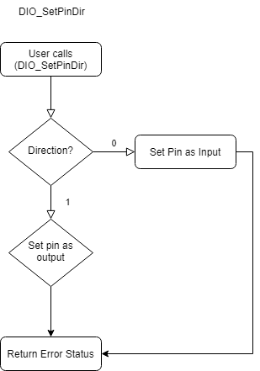DIO_SetPinDir:

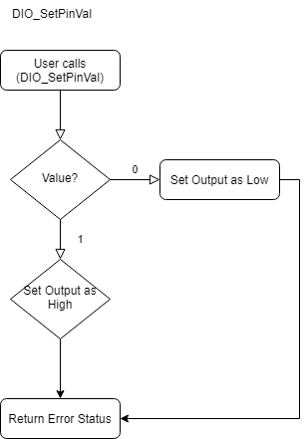DIO_SetPinVal:

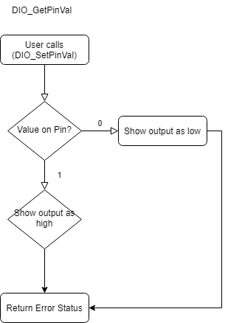DIO_GetPinVal:

* **IRQ**

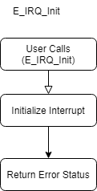IRQ_Init:

IRQ_SetCallback:

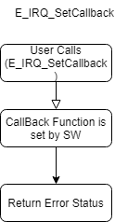

* **SWITCH**
* **SWITCH_Init**

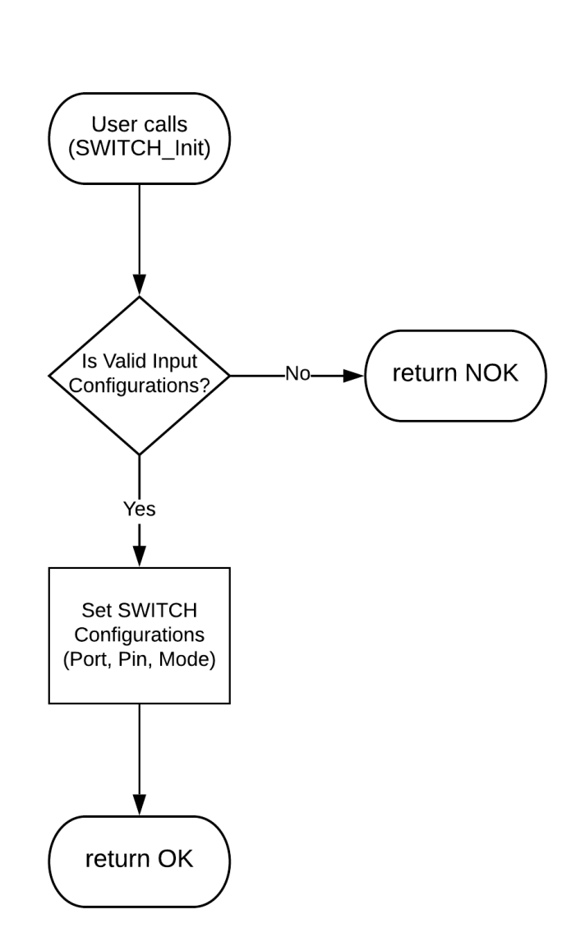

* **SWITCH_Read**

